

**K. J. SOMAIYA COLLEGE OF ENGINEERING, VIDYAVIHAR, MUMBAI 400077**

(AUTONOMOUS COLLEGE AFFILIATED TO UNIVERSITY OF MUMBAI)

**SOLAR BASED BOILERS**

A PROJECT REPORT SUBMITTED UNDER THE COURSE OF ENVIRONMENTAL STUDIES TO THE DEPARTMENT OF

SCIENCE AND HUMANITIES

**FE SEM II (2015-16)**

GUIDE – DR.DARSHAN HABALE

CO-GUIDE – PROF.MONISH DESHPANDE

**SUBMITTED BY –**

**NAME ROLL NUMBER**

**UMANG RUPARELIYA 1511105**



**K. J. SOMAIYA COLLEGE OF ENGINEERING, VIDYAVIHAR, MUMBAI 400077**

(AUTONOMOUS COLLEGE AFFILIATED TO UNIVERSITY OF MUMBAI)



**SOLAR BASED BOILERS**

Project Report submitted under the course of Environmental Studies’ Mini Project by

Group-8Batch-B2 Branch-COMPS

**BHAVIK PARMAR - 1511100**

**UMANG RUPARELIYA - 1511105**

|  |  |
| --- | --- |
| ***Guide***  ***DR.DARSHAN HABALE***  *Asst. Professor*  *Science and Humanities* | ***Co-Guide***  ***PROF.MONISH DESHPANDE***  *Asst. Professor*  *Science and Humanities* |

– PERMISSION TO USE –

In presenting this thesis in partial fulfillment of the requirements for grading in the EVS Mini Project, we agree that the Libraries of this Institute may make it freely available for inspections. We further agree that permission for copying of this thesis in any manner, in whole or in part, for scholarly purposes may be granted by the professor or professors who supervised our thesis work, or in their absence, by the Head of the Department or the Principal in which our thesis work was done. It is understood that any copying or publication or use of this thesis or parts thereof for financial gain shall not be allowed without our written permission. It is also understood that due recognition shall be given to us and to K J Somaiya College Of Engineering in any scholarly use which may be made of any material in my thesis. Requests for permission to copy or to make other use of material in this thesis in whole or on part should be addressed to: Head of the Department of S&H AND Professor In Charge of this EVS Project, KJSCE, Vidyavihar, Mumbai – 400077.

Group-8 Batch-B2 Branch-COMPS

Date- 1/04/2016

**DEDICATED TO:**

*TEACHERS, PARENTS, ANDPEOPLE WHO HAVE PLAYED A VITAL ROLETO NOURISH OUR LIVES.*

**Authors:**

Umang Rupareliya.

**INDEX OF CONTENTS**

1. **Acknowledgements**
2. **Chapter 1 – Introduction and Background**
   1. The need for research/ Project – A brief introduction.
   2. Background to the topic.
   3. A brief overview
   4. Other if any -
3. **Chapter 2 – Methods and methodology**
   1. Methodology followed
   2. Keywords/Terms
4. **Chapter 3 – Results & Discussion**
5. **Chapter 4 – Conclusions and Recommendations**
6. **Chapter 5 – Future work / Action plans**
7. **Chapter 6 – Bibliography and References**
8. **Appendices**
9. **Miscellaneous**

**ACKNOWLEDGEMENTS**

*We are using this opportunity to express our gratitude to everyone who supported us throughout the course of this EVS project. We are thankful for their aspiring guidance, invaluably constructive criticism and friendly advice during the project work. We are sincerely grateful to them for sharing their truthful and illuminating views on a number of issues related to the project.*

*I would like to thank our project guide Dr. DarshanHabale, co-guide Prof. Monish Deshpandeand our Principal Dr. ShobhaPanditand all the people who provided us with the facilities being required and conductive conditions for our EVS project.*

*We wo*uld *also like to thank our friends and family for supporting us and believing in us throughout our project.*

*Thank you.***CHAPTER 1 – INTRODUCTION AND BACKGROUND**

**1)Need for our Research**

Energy has been the most basic need for all beings to sustain a life.Energy to us are available in various forms, but we always try to convert it in the forms in which we can make the potential use of it. Thus the Solar Boiler is a kind of a device which collects energy from the sun and converts it to make the water hot.

Solar collectors are devices that produce heat from the sun.Currently they are the mosteconomic means of converting solar energy into useable energy.The heat generated bysolar collectors canbe used for pool heating, domestic hot water supply,distilling salinewater and many other purposes. Furthermore,if the operation temperature is sufficient,electric power generation can be feasible.

Domestic hot water is the second-highest energy cost in the typical household. In fact, for some homes it can be the highest energy expenditure. Solar water heating can now reduce your domestic water heating costs by **as much as 65%**

Thus:

* The Solar Boiler is environmentally-friendly.
* It does not pollute or use valuable non-renewable resources.
* Even the pump to transport heat from the collectors to the storage tank is powered by the sun.
* Solar energy is a sound **investment in everyone's future, today.**

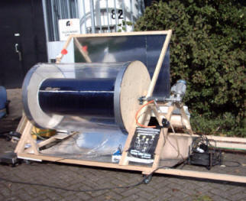

**2)Background to Topic**

The Sun supplies us with an enormous daily energy potential that exceeds primary energy consumption.This energy source is virtually inexhaustible and is also at our disposal for the next million years. Fossil fuels such as coal, natural gas, or oil are, in contrast, limited. The next generations will not be able to use them without restriction, so the sun presents itself without a doubt as the energy of the future.

The use of solar energy to heat water results in favorable basic requirements, since a household's warm water use is roughly constant throughout the year. Thus, there is a larger conformity between demand and the solar energy supply, than with the utilization for heating.

**Commercial Model Working:**

The heart of a solar boiling system is the collector. A flat-plate solar collector, the most prevalent collector form, is made up of a selectively layered absorber that serves to absorb the incoming solar radiation and transforms it into heat. This absorber is embedded in a thermally insulated box with a transparent cover (usually glass) to minimize thermal loss.

A heat conducting liquid (usually a mixture of water and non-environmentally damaging anti-freeze) flows through the absorber and circulates between the collector and the warm water storage tank. Thermal solar energy systems will be brought into operation through a solar automatic controller. As soon as the temperature on the collector exceeds the temperature in the storage tank by a few degrees, the regulator switches on the solar circulation pump and the heat conducting liquid transports the heat received from the collector to the storage tank.

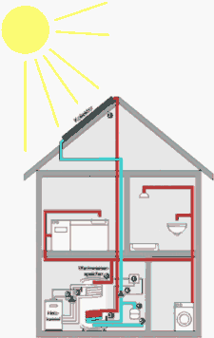

Elements of a solar boiling system for hot water:

* Automatic solar controller
* Temperature sensor on collector
* Temperature sensor on storage tank
* Solar circulation pump
* Cold water inflow
* Hot water run-off
* Expansion tank
* Temperature sensor for additional heating
* Charging circuit- solar circulation pump

**Types of Collectors:**

At this moment there are five different types of solar collectors:

1. Concentrating solar collectors-This type of solar collector consists of parabolic mirrors that concentrate the light onto aspot or a line, where the heat is generated. The parabolic mirrors work like a magnifyingglass.

2)Flat plate solar collectors-These collectors are generally used for water heating at moderate temperatures. Theyconsist of a cover made of glass or plastic and an absorber plate with attached water tubesto heat up water.

3)Evacuated tube collectors-Evacuated collectors usually have reflectors to utilize the complete surface area of around tube. These reflectors are static and do not have to be pointed at the sun. They donot concentrate but bend the light to suit the cylindrical geometry of the vacuum tube.

4)Uncovered absorbers-Uncovered absorbers are black surfaces with incorporated water tubes. They have noadditional means of retaining heat.

5)Solar ponds-A solar pond is a basin of water where convection is prevented. Water is used as aninsulator and as a heat radiation barrier.

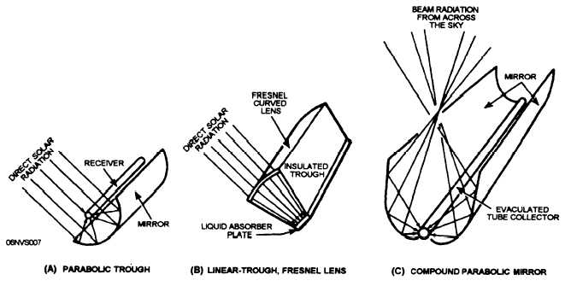

**CHAPTER 2 – METHODS AND METHODOLOGY**

**Methodology Followed:**

The type of methodology followed by our group was to create a basic model of a solar boiler which could provide us with a potential efficiency based on our environmental and financial conditions.

:

**Our Model:**

1. **Model Representation:**

We tried to create a basic representation of our model of Solar Boiler on **Autocad2016 ,**through which we found out a particular solution to our basis.

The model and its dimensions are given as follows:

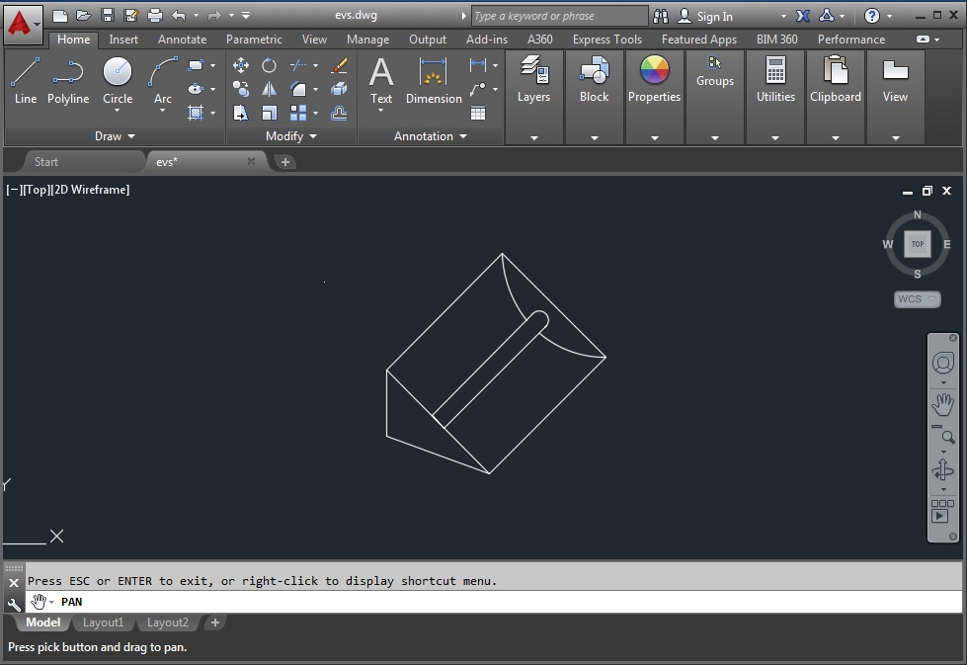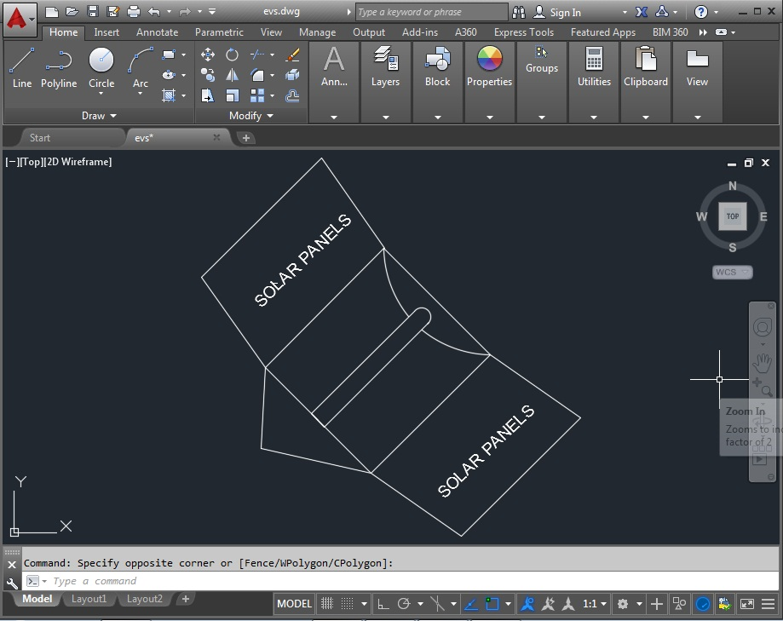

1. **Our Model:**

**Materials used:**

High graded stainless steel plate.

Steel Pipe.

Black colour oil paint.

Iron rod (for stand)

M-seal super.

**Dimensions:**

Size of the meal sheet used: 60 cm x 120 cm

Size of the parabolic sheet: 62.8 cm x 60 cm

Size of pipe used : 60 cm height

Radius of pipe used : 1.25 cm .

**Procedure:**

1.Take a metal sheet of dimensions 62.5 x 60 cm .

2.Bend it to form a parabola which satisfies the condition y^2=12x

3.Then make a stand of iron rodsof same dimensions such that it also satisfies 62.5 * 60 cm^2. so as to hold the metal sheet as it does not remain the same dize.

4.Insert a pipe made of steel of dimension 1.25 cm radius and height 60 cm

5.Then make the parabolic stainless steel glow by applying buffing.

**Working:**

A stainless steel plate is bent to form of parabola to follow the equation y2=12x.

It will be such that the axis of symmetry will be pass through the sun.

When the light rays parallel to the axis of symmetry will hit the parabola they will pass theough the focus of parabola. Therefore we will convert all the rays on the steel rod which is placed at the focus of the parabola.which will heat the rod and will heat the water in the steel rod .The stainless steel is used as it has high reflection coefficient and the rodis painted black as black coloured steel rod has high coefficient of absorption.

**Calculations:**

**Efficiency = Practical Raise in Temperature / Theorotical Raise in Temperature*100**

1)Practical Calculations:

* Radius (r) = 1.25cm.
* Length(l) = 60 cm.
* Volume = pi*r*r*h =294.5248 cu.cm.
* Density of Water = 1 gm/cc.
* Therefore Mass of water=294.5243 gms.
* Initial Temperature of water =30 C.
* Final temperature of Water = 73 C.
* Specific Heat Of Water= 4.18 J/gm.C
* Thus,Total Energy Required = MassofWater*Specific heat of water*Temperature Change

= 29.5243*4.18*43

=52937.7977 Joules.

* Time = 1 hour
* Thus, The total power=Total Energy/Total Time

=52937.7977 Joules/hr.

Heat lost in raising the temperature of steel rod

Outer diameter of steel rod=2.7 cm

Inner diameter of steel rod=2.5 cm

Outer radius =1.35 cm

Inner radius =1.25cm

Height of steel rod=60 cm

Volume of steel rod=pi*1.35*1.35*60-pi*1.25*60=pi*60*0.26=48.984 cm3.

Specific heat of steel = 0.5 J/gm.C

Density of steel rod = 8.05 gm/cm3

Energy wasted in raising the temperature of the steel rod =Mass of steel rod*specific heat of steel*rise in temperature

=48.984*8.05*0.5*43

=8477.9058 J

Stefan’s Boltzmann Law

According to Stefan’s Boltzmann law, The energy of thethermal radiation emitted per unit timebya black body ofsurface area A is given by U=$AT4where $ is a universal constant known as Stephan Boltzmannconstant,T is temperature in Kelvin and A is area of surface.

Newton’s law of cooling

Suppose ,abody of surface area A at an absolutetemperature is kept surrounding having a lowertemperatureT0.The net rate of loss of thermal energy from the body dueto radiation is :

delta U = $A(T4-T0)

If the temperature difference is small we can write T=T0+delta T

Or

T4-T0 = (T0-delta T)4 - T04

= T04(1+4 delta T/T0+ higher powers of delta T/T0) - T04

= 4 T03(T-T0)

Thus delta U =4$AT03(T-T0).

$=5.67*10-8

A=2*pi*60*1.25*1/104*60=0.0471

T0=303 , T=346

Delta U = 12.7779 J/s.

Energy lost during 1 hr in practical=12.7779*3600=46000.5262 J.

2)Theorotical Calculations:

* Total Energy received from the sun in 1 sq m area at equator=280 W/m^2
* Mumbai latitude =18.55 N.

Around 90% of the solar energy is absorbed from 0 degree to 23 degree N and S.

(by Earths observatory Nasa Govt.)

Thus, Average Heat observed during observed in Mumbai =280*90/100

=252 W/m^2

=252 J/sm^2

Thus,Average Heat observed during observed in Mumbai in 1 hour=3600*252*10^-4 J/ cm^2

=90.72 J/cm^2.

As we know, heat recieved to the water in Boiler are from two types:

* Reflection Heating.

Area of front side of boiler:

Length =60 cm ,Breadth= 45 cm

Area =2700 sq.cm.

Area of front side of rod:

Length =60 cm ,Breadth=2.5 cm.

Area = 150 sq.cm.

Effective area = Area of front side of boiler - Area of front side of rod

=2550 sq.cm.

Amount of Radiation incident on stainless steel = 2550 * 90.72

= 231336 J

Coefficient of reflection of stainless steel is 0.88.Therefore amount of radiation incident on water rod is only 88% of total radiation.

Amount of radiation reflected by stainless steel plate=231336*0.88

=203575.6 J

Coefficient of absorbtion of black painted steel rod=0.8.

Thus, only 80% of heat will be absorbed by the water rod=203575.6*80/100.

=162860.544 J.------------------(1)

* Direct Radiation Heating.

Area of rod:

Length=60 cm ,Breadth=2.5cm

Area of rod = 150 sq.cm.

Total Heat Radiated on rod = 150 * 90.72

= 13608 J

Coefficient of absorbtion of black colour steel=80%

Total heat absorbed by rod = 13608 * 0.88

= 10886.4 J----------------------------(2)

Total energy available for heating the water = Amount of radiation absorbed by the water rod by reflection through parabolic stainless steel plate + Amount of radiation directly incident on the water rod.

=162860.544 J + 10886.4 J -----(from(1) and (2))

=173746.944 J

Total rise in temperature should be ideally:

Surrounding Temperature (T0) = 30 C = 303 K.

Mass of sample water = 294.5243 gms

Specific Heat Of Water= 4.18 J/gm.C

Mass of steel Rod = 394.0314 gms

Specific heat of steel = 0.5 J/gm.C

Total energy available=Energy requiredto raise water temperature + Energy required to raise water rod temperature +Energy lost in the radiation.

Thus,

173746.944=294.5243*4.18*(T-303)+394.0314*0.5*(T-303)+0.2972*3600(T-303).

T=372.5531 K

=99.55310C

Therefore , theoretically the water temperature after 1 hour under the conditions :-

1. Sun is not moving.
2. There is a clear sky.
3. Minor losses are not considered.

should be 99.5531 0C.

**Efficiency:**

**Percentage efficiency in output of theoretical and practical is:**

= Practical rise in temp./Theoretical Rise in temperature*100

=43/(99.5531-30)*100

=61.8233%.

**Percentage of conversion of solar energy:**

**1)Practical**

= Total Energy gained by rise water temperature/Total Energy received from the sun

=52937.7977/231336+10886.4*100

=21.855%

1. **Theoretical**

Percentage of conversion of solar energy=

= Total Energy gained by rise water temperature/Total Energy received from the sun

=85627.6264/231336+10886.4*100

=35.3508%

**Chapter 3 – Results & Discussion**

* Efficiency for ideal rotating solar based boiler is near about 22% and the efficiency of our boiler is 21%
* 88%of the total heat is absorbed by the material (high graded stainless steel)which subsequently is concentrated on the rod due to its parabolic shape which heatens the water. The maximum tepmerature achieved by water in 1 hour is about 73 C.
* **Discussions:**

When the project was being architectured the questions faced were:

1.Which material is to be used for maximum efficiency?

2.What should be the shape of material for the maximum concentration of heat energy?

3.Which material should be used for pipe/tank?

4.What should be the position of pipe inlet and outlet for easier use?

5.Dimensioning, Costing, Shaping, Welding etc where the vital points of concern.

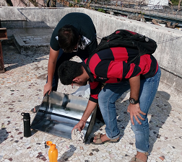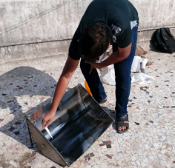

The problems were overcomed using:

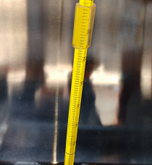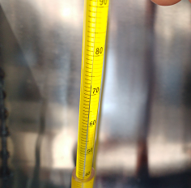Rather than using steel,having a 56% efficiency for absorbing the radiation,we chose was high graded stainless steel. For the maximum concentration of heat, the material was shaped as a parabola , and the rod was placed on the focal axis of the parabolic sheet.The material chosed for the rod was steel rod.

Problems faced during the readings were taken:

1.Position of boiler for gathering maximum heat .

2.Range of thermometer to be used.

3.What should be the time range for temperature readings?

4.Do we need to change the position of boiler after certain time due to change in initial postion of sun ?

The problems were overcomed using:

Position it just below the sun or at an angle of 45 degrees for maximum heating effect.As the temperature rise till 80 degree celcius. Therefore the range chosen was 100 degree celcius. For the perfect calculations interval of 15 minutes was taken.As the change in the position of the sun would be changing by 1 degree which would not be too significant.

**CHAPTER 4 – CONCLUSIONS AND RECOMMENDATIONS**

The model is working efficiently as per our expectations and the designed model.

**Comparison of Original model and our Working model.**

**Our Model:**

* Efficiency is **21%.**
* Costing is near about **4-5 K**.
* Our model do not have acrylic covering on tank for storing heat.
* It requires manual work for inlet and outlet of water.
* The dimensions of our model are 62.5 * 60 cm for stainless steel.
* Amount of water being heated is approx. 300 ml (can be varied).

**Original Model:**

* Efficiency is **23%.**
* Costing is near about **12-13 K**.
* They have acrylic covering on tank for storing heat.
* It has an automated mechanism for inlet and outlet of water.
* The dimensions of these models depends on requirements.
* Amount of water being heated is variable as per requirement.

**Drawbacks of our model**

* Amount of water which is heated by changing is comparatively low,if the amount is increased the size of tank efficiency decreases.
* Inlet of water in our model requires manual work.
* Change in the position of sun affects efficiency , as the spot of accumulation of rays changes.
* There is no motor for continuous inlet and outlet of water.

**CHAPTER 5 – FUTURE WORK / ACTION PLANS**

* From the drawbacks, we came up with the advancements in the actual model & designed rotating solar boiler.
* A motor can be attached to the reflector to rotate it in the direction of the sun (i.e. a degree in every four minutes).
* This can help to improve the efficiency of the boiler as it would absorb more amount of heat than the conventional one.
* In the actual solar boiler we added two solar panels at the ends of the reflector to produce energy.
* As boiler will rotate even the panels will rotate and huge amount of electricity can be produced and efficiency increases.

**aa**

BIBLIOGRAPHY AND REFERENCES

**Books :**

Environmental Studies Textbook,

Solar Photovoltaics by Chetan Singh Solank,

Do it yourself-solar and wind energy.

**Websites:**

[www.wikipedia.com](http://www.wikipedia.com),

[www.betterenergy.org](http://www.betterenergy.org),

www.solarenergy.com,

www.eosweblarc.nasa.gov.